# Return to Work (RTW) Case Scenarios

## Case Scenario 1

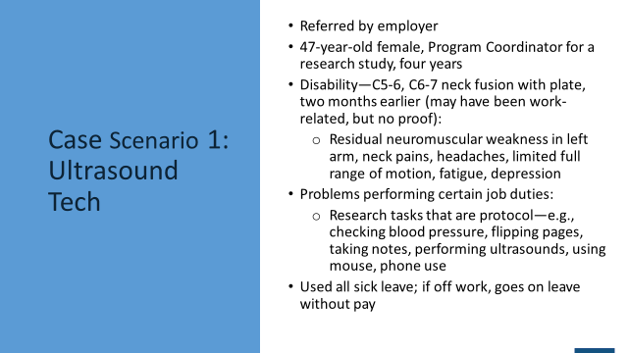

Julie is a 47-year-old female who was referred for services by her employer. She has worked for her employer for four years. Julie currently works as a program coordinator for a cardiac research study and is about to take on the responsibilities of an additional research study. Both studies deal with arthrosclerosis of the neck veins. In addition to being the program coordinator, Julie also performs such tasks as recruitment coordinator, data manager, back-up ultrasound technician, and back-up research interviewer. Actually, Julie is the only ultrasound technician for the cardiac research study since the other technician recently retired. In her office, Julie supervises two recruiters, spends considerable time on the telephone, processes paperwork, and works on the computer. She has to file heavy charts, print out reports, and fill in as a back-up person if the clinic is short-staffed.

Julie is having problems performing several of her job duties due to pain and residual weakness on her left side as a result of a C5-6 and C6-7 neck fusion acquired two months ago. Julie states that she had been experiencing severe headaches and, after seeing several doctors, was finally told that she had two herniated discs that had to be corrected with a fusion and a plate; hence the need for a neck fusion. She returned to work part-time about one month ago and has been experiencing increased pain and headaches since she returned to work. Julie’s frustration and anxiety also have increased because her headaches have returned. She states that she has been diagnosed with residual neuromuscular weakness in her left arm. She does not yet have full range of motion in this arm either.

I visited Julie at her work site and noticed that the two desk areas that she uses to input data are not appropriate in terms of their height and set-up. Also, as Julie was demonstrating how she performed the research interview with patients and performed the ultrasounds, many problems became obvious. Julie noticed pain in her neck when trying to take a person’s blood pressure, perform the research interview, and take notes and flip pages that the participant had to read. She also experienced fatigue and pain in her neck when performing the ultrasound due to the height of the table relative to the chair she uses, as well as the height of the machine. Julie uses two different ultrasound rooms and machines. Of note: research interviews and ultrasound procedures are performed under very controlled conditions so that the study can be valid.

Finally, Julie has used all her sick leave and when she is absent from work, she is off work without pay. She is trying to work as many hours as she can but is having difficulty staying at work more than four hours a day because of pain and headaches.

## Case Scenario 2

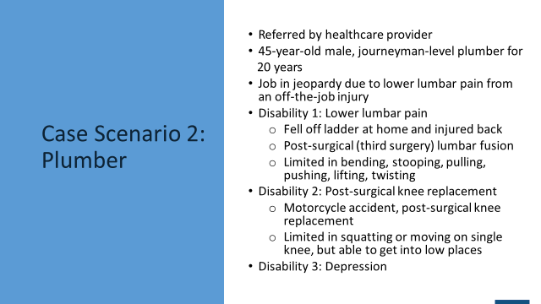

Jack is a 45-year-old male with lower lumbar pain. Jack graduated from high school and began working with Slaton’s Mechanical when he was 21 years old through an apprenticeship. He has no other post-secondary training. As a result of completing his apprenticeship, Jack earned a journeyman’s license in plumbing and has worked for Slaton’s Mechanical for more than 20 years. Approximately six months ago, Jack fell off a ladder at his house and injured his lower back. At the time of the injury, he was told he had several herniated discs that were pressing against his sciatic nerve as well as nerves leading to his legs. Jack tried to return to work after his back injury, but his pain was too severe and he could not perform his job tasks to the necessary level.

Jack’s company offered short-term disability and long-term disability as an employee benefit. Jack decided he needed to access the short-term disability assistance while he continued to receive medical treatment. After six months, Jack tried to return to work for a few months, but the pain continued. He went off work again, went back on short-term disability, and had another surgery. To date, the surgery has not been helpful.

Jack really enjoys his job and enjoys working for his employer. However, Jack’s back pain continues to worsen. At this time, Jack is having issues with tingling and shooting pain in his lower back and legs. Although he is still limited in what he can do, Jack wants to return to work, and Slaton’s Mechanical wants to bring him back to work. There are concerns on the part of both Jack and Slaton’s Mechanical around his personal safety, safety to others, and his ability to perform the required job tasks. Jack and Slaton’s Mechanical are seeking assistance in returning to work.

*This handout was prepared for the U.S. Department of Labor (DOL) Office of Disability Employment Policy and Retaining Employment and Talent After Injury/Illness Network (RETAIN) state grantees, by the American Institutes for Research under DOL Contract Number 1605DC-18-F-00429. The views expressed are those of the authors and should not be attributed to DOL, nor does mention of trade names, commercial products, or organizations imply endorsement of same by the U.S. Government.*